**Task 2 Report**

Sri Harshitha P, Kumaraguru College of Technology.

**Step 1: Basic Exploration:**

* Dataset contains 1907 records with 13 columns.
* PS2,PS,X360,PS3,Wii,DS are the top five among 22 platforms of games.
* Sports and Action are the top two Genres.
* There are 94 publishers.
* Gaming industry has seen a remarkable growth since 1995.

**Step 2:**

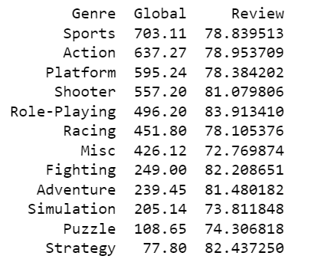

* The "Sports" and "Action" genres have relatively high global sales, with 703.11 million and 637.27 million units, respectively. This indicates a strong demand for these types of games.
* Maximum reviews are from Role-Playing, The "Role-Playing" genre has the highest average review score of 83.91. This suggests that role-playing games are well-received by critics on average.
* The "Misc" and "Puzzle" genres have lower global sales, with 426.12 million and 108.65 million units, respectively. These genres may have a smaller audience or market share.
* The "Fighting" and "Strategy" genres have relatively high average review scores of 82.21 and 82.44, respectively. This suggests that these genres tend to receive positive critical acclaim.

**SALES BY GENRE AND PLATFORM:**

* "Wii Sports" on the Wii platform had the highest global sales at 230.96 million units, making sports games on Wii popular.
* The "Shooter" genre on Xbox 360 ranked second with 198.56 million units in global sales, indicating strong performance in shooter games.
* PS2 excelled in both sports (189.63 million units) and action (181.17 million units), while the "Wii Misc" genre reached 137.43 million units in global sales.
* SNES excelled in "Puzzle" and "Adventure" genres with high global sales (1.70 and 6.03 million units, respectively) and received excellent average review scores of 94.000.
* Dreamcast (DC) platform saw success in "Action" and "Sports" genres with global sales of 1.14 and 2.29 million units, respectively, and received high review scores (93.630 and 93.015, respectively).
* N64 platform achieved strong global sales in "Adventure" (10.96 million units) and "Role-Playing" (1.38 million units) genres, both with high review scores (93.500 and 92.000, respectively).

**Top Genre in various regions:**

* In North America, the top-selling genres are Sports (354.62), Shooter (333.40), and Action (320.88), indicating a strong interest in competitive and action-packed gaming experiences, making it essential for developers to focus on these genres for success in the region.
* In Europe, Sports (221.09), Action (205.91), and Shooter (155.89) genres also dominate. Developers should prioritize these genres when targeting European markets.
* Japan's gaming market is distinctive, with Role-Playing (169.32), Platform (104.17), and Sports (56.47) genres leading in sales. Developers entering the Japanese market should create content aligned with the preferences of Japanese gamers, such as immersive role-playing experiences and platformers.

**Top Platform in various regions:**

* In North America, the top platforms with the highest sales are PS2 (400.07 million units), X360 (335.44 million units), and Wii (292.66 million units). Developers should consider these platforms for North American game releases.
* In Europe, PS2 (268.53 million units), Wii (191.73 million units), and PS3 (160.70 million units) lead in sales, indicating a diverse market.
* In Japan(106.48 million units), NES (80.09 million units), and PS (64.41 million units) ar top-selling platforms. Developers should align with these platform preferences to succeed in the Japanese market.